Module: Digital Communications and Transmission Practical: 3

Semester: 4 Stage: 2

Lab 3: Sampling, Quantisation and DAC Reconstruction

AIM:
In this practical, we will build a version 4-Bit Pulse Code Modulation (PCM)

OBJECTIVES:
To design, implement, and analyse a 4-bit Pulse Code Modulation (PCM) system using a MSP430 microcontroller and discrete analogue electronics. After the completion of this experiment, students will have good knowledge of the three main parts of PCM (Pulse Code Modulation):

- Implement sampling routines using the microcontroller hardware timers.

- Execute quantization and binary encoding by mapping 10-bit ADC data to a 4-bit parallel output.

- Reconstruct analogue signals from parallel digital data using a summing amplifier circuit.

- Evaluate system limitations including quantization noise, voltage scaling constraints, and aliasing distortion.

EQUIPMENT REQUIRED:
Signal Generator – MP750510
Oscilloscope –
MSPG2553 Development Board
741 Op-Amp
Resistors:?

THEORY:
Sampling The process of measuring the amplitude of a continuous-time signal at discrete instants. It converts a continuous-time signal to a discrete-time signal.
Quantizing Representing the sampled values of the amplitude by a finite set of levels. It converts a continuous-amplitude sample to a discrete-amplitude sample.
Encoding Designating each quantized level by a (binary) code.

The process of converting the amplitude of each pulse into a stream of 1s and 0s is called Pulse Code Modulation (PCM).

Part 1: Analogue Input Generation

- Turn on your signal generator(MP750510) and configure it to output a Sine Wave.
- Set the frequency precisely to 2 Hz.
- Adjust the offset and amplitude so the signal spans a strict range of 0V to 3V (do not exceed 3.3V to protect the MCU).
- Verify the waveform settings using your oscilloscope channel 1 before connecting it to the microcontroller.

Part 2: Hardware Configuration & Sampling Routine
- Connect your 2 Hz analogue input signal directly to pin P1.4 (ADC Input A4) on the MSP430. Do not turn on yet.

- Flash the provided code to initialize a 20 Hz sampling clock utilizing the internal hardware Timer_A.

The main body of code is shown below, P1.4 is setup as the ADC input, while P1.0, 1.1, 1.2 and 1.3 is setup as output. In a true PCM system the digital output data is transmitted in serial. For our setup, the digital data is being transmitted in 4-Bit parallel form.

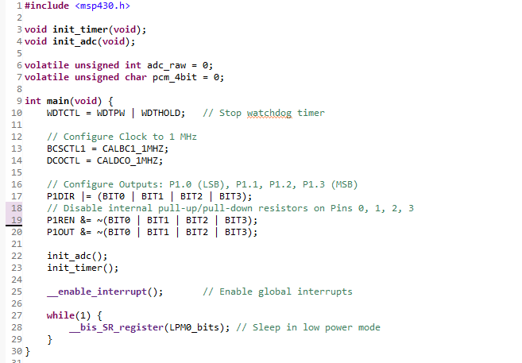

Initialisation of the ADC

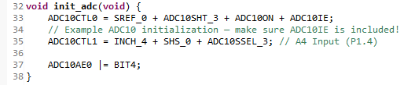

Initialisation of the timer for 20Hz Sampling

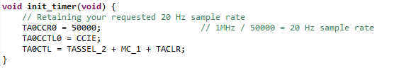

Part 3 Quantization and Encoding of the signal:
- The onboard MSP430 Successive Approximation Register (SAR) ADC yields a 10-bit resolution (\(0 - 1023\)).

- Add the following interrupt service routines (ISRs) to your source code to downsample the resolution to 4-bit ((0 – 15 levels)) via a bitwise right-shift operations ((1024 / 64 = 16 levels)).

Timer interrupt vector, upon timer firing, the ADC is triggered to take a sample

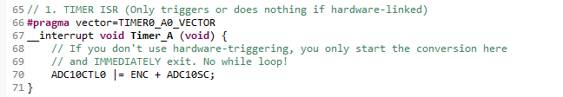

Quantisation for 4-Bit, scale 10-Bit to 4-Bit by shifting right 6 places, which is the same as dividing by 64

10 - Bit = Resolution of 1024
4 - Bit = Resolution of 16

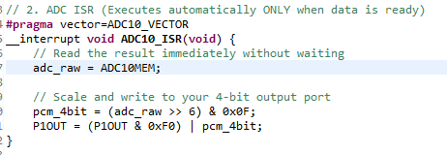

Note, unlike the traditional PCM where the digital output is in serial form, our setup here has the digital output in parallel form.

Note that the code has configured the 4 output port pins for the transmission of the 4-Bit data.

With the analogue signal connected to P1.4, programme the MSP430 and scope the output pins to determine if your output is as expected.

- Validation Check: Apply fixed DC test voltages (0V, 1V, 2V and 3V) to pin P1.4. Measure pins P1.0 through P1.3 with a multimeter or digital oscilloscope to verify that the binary outputs track perfectly with your expected values.

Part 4: Discrete DAC Hardware Reconstruction

The final section of work is to convert the digital signal back to an analogue signal that resembles the original analogue input signal.

The Digital to Analogue conversion (DAC) can be carried out using a 4 channel summing amplifier. From Year 2 - Analogue Circuit Design you will remember that the summing amplifier is based on the inverting amplifier.

- Wire up the 4-bit -weighted summing amplifier schematic shown below on your prototyping breadboard

- Connect digital output lines BIT0 (LSB) through BIT3 (MSB) from your MSP430 header pins directly to the matching input resistors.

- Remember to power up the operational amplifiers using a dual +/-15V supply

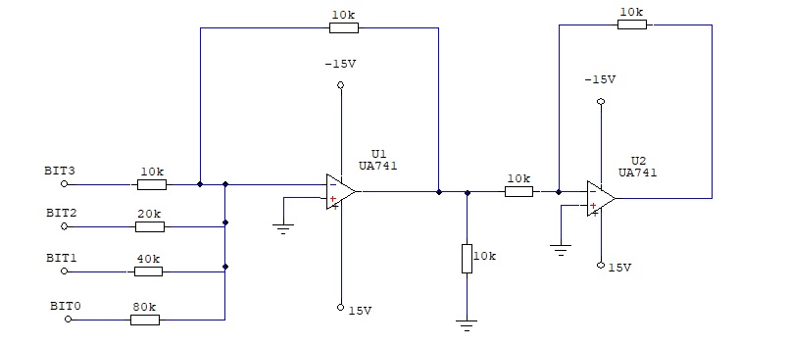
Fig 1 – Summing Amplifier

Note: Each of the binary 1(highs), supplied by the MSP430 is 3.3Volts

Part 5: Analysis and Questions

Question 1: What would the output be for binary value of 1,1,1,1

Note the summing amplifier formula below
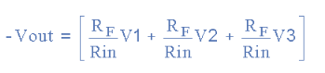

Question 2: Explain the purpose of the second op-amp in the circuit, note the resistor values which control the gain of the second op-amp will need to changed.
Remember the maximum voltage output from the DAC must be 3V for binary 1,1,1,1.

Question 3: Determine the precise scaling factor required, and calculate the exact replacement value for the feedback resistor R_{F} on the second amplifier to achieve this.

Part 6: Verification and Testing

- Waveform Capture: Probe the source input signal (P1.4) alongside your finalized hardware reconstruction output concurrently using the oscilloscope. Save clear screenshots showing both waveforms together.

- (Nyquist Limit Evaluation): Slowly increase the signal generator frequency above the baseline 2 Hz setting while monitoring the reconstructed output wave.

- Identify and document the precise frequency boundary where noticeable aliasing and waveform distortion first manifests. Note down how this distortion impacts the output shape

Part 7: Conclusion

- Briefly explain what has been achieved and verified.
- The outcome of the analyse, quantisation noise, Nyquist sampling theorem.
- Any hardware trade-offs.
- Output parallel vs serial.

